PROGRAM 3 : Multi-Product Price Fluctuation Analysis
1. Problem Statement
Develop a Python program to analyse historical prices of multiple products stored in lists. The program calculates the percentage change in price between consecutive periods, identifies the maximum price fluctuation for each product, compares price changes across products, and flags products whose percentage fluctuations exceed a specified threshold.
The program uses Python concepts such as computational thinking, algorithms, flowcharts, pseudocode, variables, data types, operators, conditional statements, loops, strings, pattern generation, lists, nested lists, tuples, tuple operations, and unpacking.
2. Objectives
- Store historical prices of multiple products using Python lists.
- Calculate percentage price changes between consecutive periods.
- Identify the maximum price increase or decrease for each product.
- Compare price fluctuations across different products.
- Flag products whose maximum percentage fluctuation exceeds a given threshold.
- Display a formatted report showing product prices and fluctuations.
- Apply Python programming concepts to analyse price trends efficiently.
3. Assumptions
Item | Assumption
Products | Three products
Historical data | Four price observations per product
Price unit | Indian rupees (₹)
Price data | Sample historical prices
Percentage change | \((\text{New Price}-\text{Old Price})/\text{Old Price}\times100\)
Price fluctuation | Absolute value of percentage change
Maximum fluctuation | Largest absolute percentage change between consecutive observations
Threshold | 10%
Flag condition | Maximum fluctuation greater than the threshold
Price values | Must be positive numbers
A positive percentage change indicates a price increase, while a negative percentage change indicates a price decrease. The maximum fluctuation is determined using the absolute percentage change, so both increases and decreases are considered.
4. Computational Thinking
- Decomposition: Divide the task into storing prices, calculating percentage changes, finding maximum fluctuations, and flagging products.
- Pattern recognition: Identify repeated increases or decreases in product prices.
- Abstraction: Focus on product names, historical prices, percentage changes, and the threshold.
- Algorithmic thinking: Follow a sequence of calculations to compare products and generate the report.
5. Algorithm
- Start the program.
- Create a list of product names.
- Store the historical prices of each product in a nested list.
- Set the fluctuation threshold to 10%.
- For each product, compare consecutive prices.
- Calculate the percentage change using the percentage change formula.
- Store each percentage change in a list.
- Find the maximum absolute percentage change for each product.
- Compare the maximum fluctuation with the given threshold.
- Flag products whose maximum fluctuation is greater than 10%.
- Display the percentage changes, maximum fluctuations, and flagged products in a formatted report.
- Stop the program.
6. Flowchart
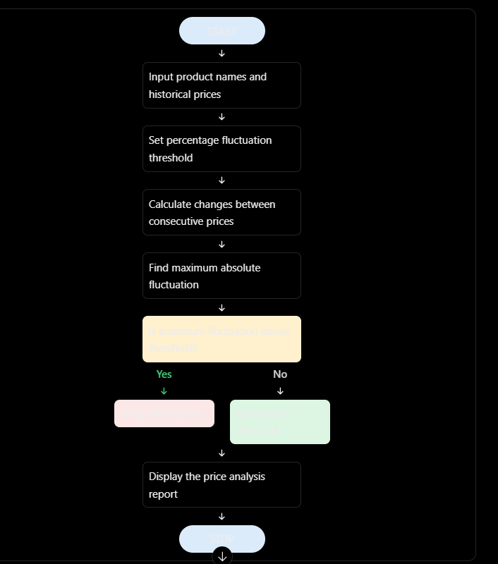

7. Pseudocode
BEGIN

SET product_names
SET historical_prices
SET threshold = 10

FOR each product and its prices

CREATE empty percentage_changes list

FOR each pair of consecutive prices
percentage_change =
(new_price - old_price) / old_price * 100

ADD percentage_change to percentage_changes
END FOR

maximum_fluctuation =
MAXIMUM absolute percentage change

IF maximum_fluctuation > threshold
FLAG product
ELSE
MARK product as within threshold
END IF

DISPLAY product and its price changes
END FOR

DISPLAY all flagged products

END

8.PYTHON SOURCE CODE

# Case Study 63: Multi-Product Price Fluctuation Analysis

# Product names
products = ["Laptop", "Mobile", "Headphones"]

# Historical prices in rupees
historical_prices = [
[100, 110, 105, 125],
[200, 190, 210, 205],
[50, 52, 51, 53]
]

# Threshold percentage
threshold = 10

# Store analysis results
analysis_results = []
flagged_products = []

print("===== MULTI-PRODUCT PRICE FLUCTUATION ANALYSIS =====")

# Process each product and its historical prices
for product, prices in zip(products, historical_prices):

percentage_changes = []

# Calculate changes between consecutive prices
for i in range(len(prices) - 1):
old_price = prices[i]
new_price = prices[i + 1]

change = ((new_price - old_price) / old_price) * 100
percentage_changes.append(change)

# Find maximum absolute fluctuation
max_fluctuation = max(
abs(change) for change in percentage_changes
)

# Identify the period with maximum fluctuation
max_index = max(
range(len(percentage_changes)),
key=lambda i: abs(percentage_changes[i])
)

max_change = percentage_changes[max_index]

# Check threshold
if max_fluctuation > threshold:
status = "FLAGGED"
flagged_products.append(product)
else:
status = "Within threshold"

# Store results as a tuple
analysis_results.append(
(product, percentage_changes, max_fluctuation,
max_change, status)
)

# Display formatted report
print(f"\nFluctuation Threshold: {threshold}%")
print("\n===== PRICE ANALYSIS REPORT =====")

for product, changes, maximum, max_change, status in analysis_results:
print(f"\nProduct: {product}")
print("Percentage Changes:", end=" ")

for change in changes:
print(f"{change:+.2f}%", end=" ")

print(f"\nMaximum Fluctuation: {maximum:.2f}%")
print(f"Change Direction: {'Increase' if max_change > 0 else 'Decrease'}")
print(f"Status: {status}")

# Display flagged products
print("\n===== FINAL RESULT =====")

if flagged_products:
print("Products exceeding threshold:")
for product in flagged_products:
print("-", product)
else:
print("No products exceeded the threshold.")

print("\nAnalysis completed successfully.")

9. Test Cases
Test case | Price pattern | Expected result
1 | Prices increase by more than 10% | Product is flagged
2 | Prices decrease by more than 10% | Product is flagged
3 | All changes are below 10% | Product remains within threshold
4 | Consecutive prices are equal | Percentage change is 0%
5 | A product has both increases and decreases | Largest absolute percentage change is identified
Sample test data
Test Case 1 — Laptop
Prices: [100, 110, 105, 125]
- Change from 100 to 110 = +10%
- Change from 110 to 105 = −4.55%
- Change from 105 to 125 = +19.05%
Expected result: Maximum fluctuation is 19.05%, so the product is flagged.
Test Case 2 — Mobile
Prices: [200, 190, 210, 205]
- Change from 200 to 190 = −5%
- Change from 190 to 210 = +10.53%
- Change from 210 to 205 = −2.38%
Expected result: Maximum fluctuation is 10.53%, so the product is flagged.
Test Case 3 — Headphones
Prices: [50, 52, 51, 53]
Expected result: Maximum fluctuation is 4%, so the product remains within the threshold.

10. Expected Output
When you run the Python program with the given sample data, the expected terminal output is:
=
===== MULTI-PRODUCT PRICE FLUCTUATION ANALYSIS =====

Fluctuation Threshold: 10%

===== PRICE ANALYSIS REPORT =====

Product: Laptop
Percentage Changes: +10.00% -4.55% +19.05%
Maximum Fluctuation: 19.05%
Change Direction: Increase
Status: FLAGGED

Product: Mobile
Percentage Changes: -5.00% +10.53% -2.38%
Maximum Fluctuation: 10.53%
Change Direction: Increase
Status: FLAGGED

Product: Headphones
Percentage Changes: +4.00% -1.92% +3.92%
Maximum Fluctuation: 4.00%
Change Direction: Increase
Status: Within threshold

===== FINAL RESULT =====
Products exceeding threshold:
- Laptop
- Mobile

11. Conclusion
The Multi-Product Price Fluctuation Analysis program analyses historical prices of multiple products using Python. It calculates percentage changes between consecutive prices, identifies the maximum price fluctuation, and flags products whose fluctuations exceed the specified threshold.

